**Chapter 5**

**Design**

**5.1 Architectural design**

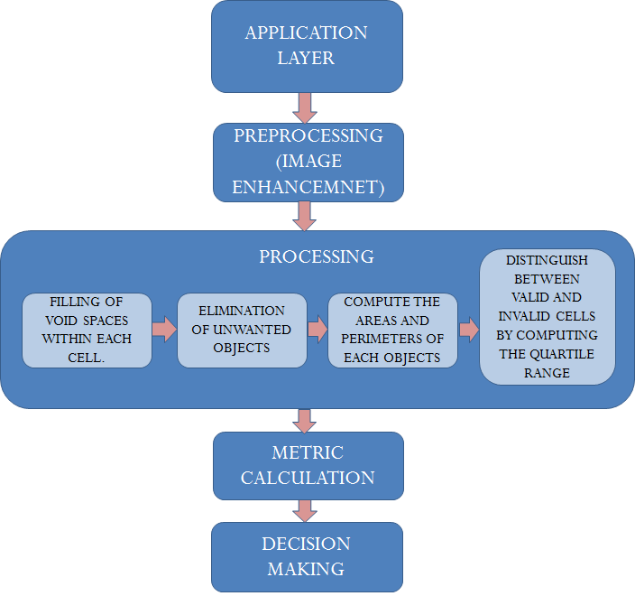

Fig. 5.1 Architectural design

The project consists of various functional stages shown in the form of modules in the diagram above. These modules function in quorum to achieve the desirable output. The explanations of each of the modules are as follows:

Application layer:

This layer acts as the interface between the user and the internal logic of the software. The GUI is implemented on this layer. It allows the user to enter in the basic details regarding the patient and also input the microscopic blood image. After calculations and internal classification, we obtain a detailed report.

Preprocessing:

This module is responsible for performing histogram stretching operation, conversion of the image into binary form and finally applying filtering the image to discard the unwanted objects.

Processing:

* Filling void space:

After conversion to grayscale, there are several cells with void spaces at the center. This has to be filled using imfill operator in MATLAB. This would help in accurate computation of the cell area.

* Elimination of unwanted objects:

The microscopic image contains cells and object other than RBCs. These objects are filtered out by using bwareaopen function in MATLAB, which removes objects having an area below a specified threshold. It also eliminates noise and other minute unwanted components.

* Computing the areas and perimeters:

The objects in the image (which are the connected components) are identified using the bwconncomp function. The area and perimeter of each of these objects are obtained by using regionprop function. Thus we obtain the area and perimeter of each RBC. This is then used assign a metric based on the shape of the cell.

* Distinguishing between valid and invalid cells:

Based on the area obtained in the above step, we determine the cells that will be eligible for the metric calculation (which we term as a valid cell). Now the objects that can be classified as an outlier based on statistical definition are not considered for further processing (which we term as an invalid cell). The metric is applied on the resulting valid cells and we thus obtain the count of normal and abnormal cells. This metric is calculated by the formula 4*pi*area/perimeter2, and its value ranges between 0 and 1. Higher the value, more circular is the image. The value thus indicates the circularity of the object and can be used to obtain the count of normal and abnormal cells.

Metric calculation:

This metric allows us to estimate the shape of the object. This metric is calculated by the formula 4*pi*area/perimeter2, and its value ranges between 0 and 1. Higher the value, more circular is the image. So a typical RBC would have a metric higher than 0.82 whereas an abnormally RBC would have a much lower metric of about 0.4 – 0.5. The value thus indicates the circularity of the object and can be used to obtain the count of normal and abnormal cells.

Decision making:

Based on the metric above, a decision is made on whether the particular cell is normal or not. A metric of 0.75 is used as the threshold lower-bound for classifying a cell as normal. After obtaining the count of all the normal and abnormal cells, if the ratio of abnormal to normal is higher than 1:10, we arrive at the conclusion that the given sample is anaemic.

**5.2 User Interface:**

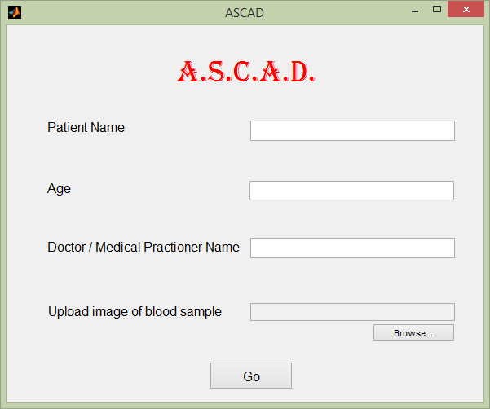

Fig. 5.2.1. User interface